Project Overview: CAN-Bus Integrated Ultrasonic Sensing System
Objective: Developed an end-to-end data communication pipeline utilizing the Controller Area Network (CAN) protocol to transmit real-time sensor data from an edge device to a web-based dashboard.
Technical Specifications
- Edge Hardware: Arduino Uno, HC-SR04 Ultrasonic Sensor.

- Communication Stack: CAN 2.0A (Standard 11-bit identifier), SPI protocol.

- Gateways: MCP2515 CAN Controllers (Transmitter/Receiver pair).

- Server Side: Raspberry Pi 3, Flask (Python), SQLite, HTML/CSS.

- DevOps: Git/GitHub for cross-platform version control.

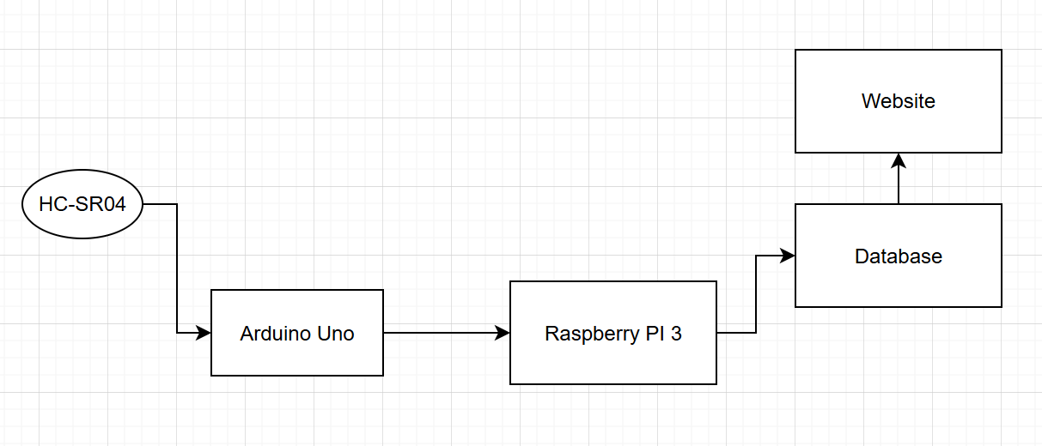
Figure 1: Functional diagram of distance sensor project

System Architecture & Implementation
1. Data Acquisition and Local Transmission
The system initiates by measuring distance via an HC-SR04 ultrasonic sensor. The Arduino Uno processes this signal and interfaces with an MCP2515 CAN module via the SPI communication protocol.
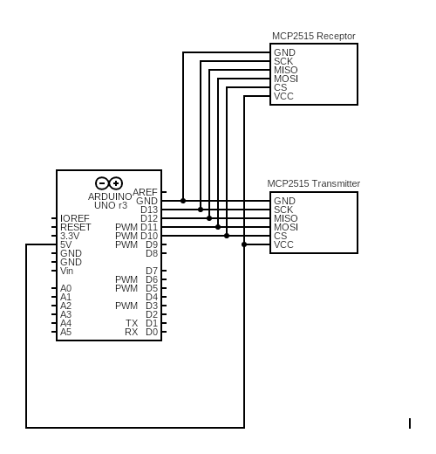
Figure 1: CAN Communication system

2. Robust CAN-Bus Communication
Data is transmitted between two MCP2515 modules using the CAN 2.0A standard.

- Data Integrity: The protocol utilizes a 16-bit Cyclic Redundancy Check (CRC) and an Acknowledgment (ACK) slot to ensure error-free transmission.
- Prioritization: The system architecture supports message prioritization where lower Identifier (ID) values receive higher bus priority.
- Frame Structure: Each transmission is encapsulated in a standard CAN frame, including Start of Frame (SOF), Control bits (DLC), and a payload of up to 8 bytes.

Below is a standard CAN data frame with 11 bits identifier (CAN 2.0A), which is the type used in most cars. The extended 29-bit identifier frame (CAN 2.0B) is identical except the longer ID. It is e.g. used in the J1939 protocol for heavy-duty vehicles.
Note that the CAN ID and Data are highlighted - these are important when recording CAN bus data, as we will see below

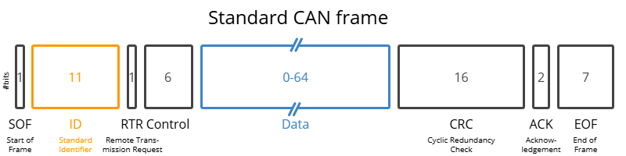

- SOF: The Start of Frame is a 'dominant 0' to tell the other nodes that a CAN node intends to talk
- ID: The ID is the frame identifier - lower values have higher priority
- RTR: The Remote Transmission Request indicates whether a node sends data or requests dedicated data from another node
- Control: The Control contains the Identifier Extension Bit (IDE) which is a 'dominant 0' for 11-bit. It also contains the 4 bit Data Length Code (DLC) that specifies the length of the data bytes to be transmitted (0 to 8 bytes)
- Data: The Data contains the data bytes aka payload, which includes CAN signals that can be decoded for information
- CRC: The Cyclic Redundancy Check is used to ensure data integrity
- ACK: The ACK slot indicates if the node has acknowledged and received the data correctly
- EOF: The EOF marks the end of the CAN frame

3. Database Integration and Web Visualization
The receiving node passes the telemetry to a Raspberry Pi 3 server via a serial connection.

- Data Persistence: A C-based serial reader parses incoming strings and logs them into an SQLite database (distance.db) with unique IDs and timestamps.
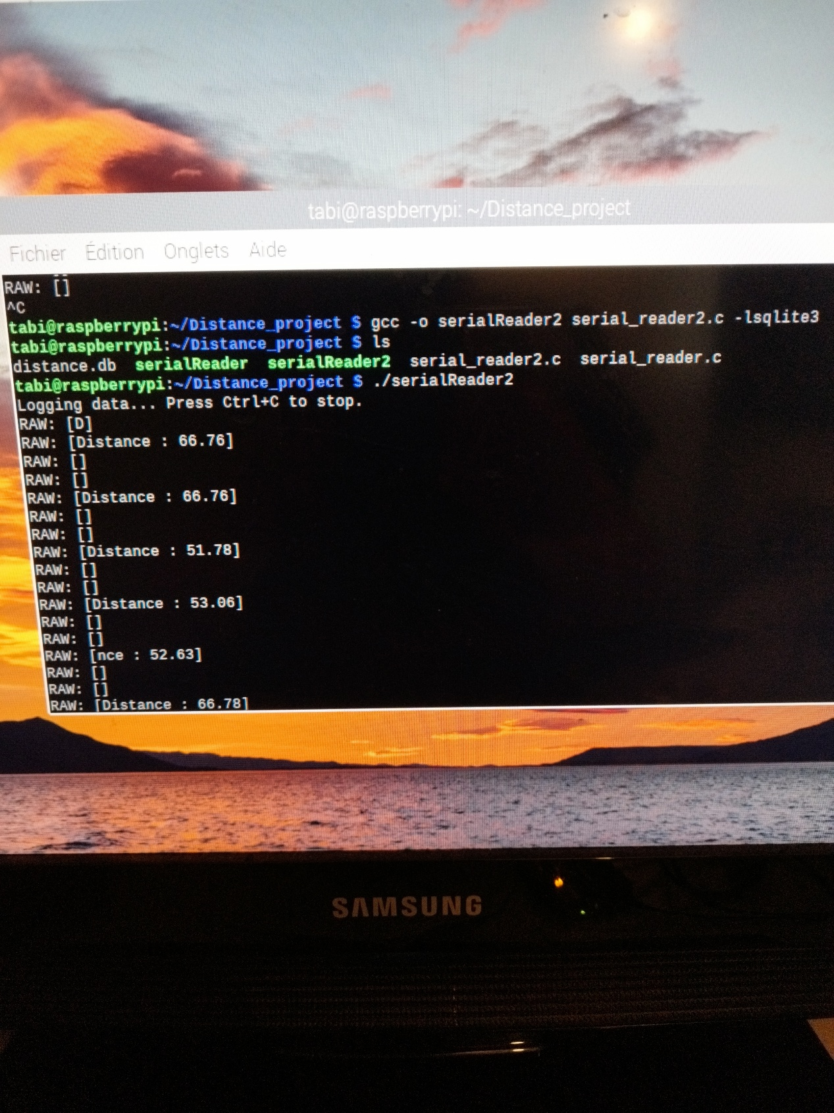

- Full-Stack Dashboard: A Flask web application queries the database to display the 50 most recent measurements in a clean, tabular HTML format.

